**Conversation Guide: Digital Health Modernization Discovery Research**

**Bold text identify the moderator’s questions.**

*Text in italics are Emily’s observations and interpretations of the participant.*

[Text in brackets are interpretations in participants’ direct quote.]

**Background (5 minutes)**

To get started, I’d like to get a little background information about you, and your experience with the VA.

1. **Can you tell me a little bit about yourself?**

Related to the VA, I was in the Army from ‘77 to ‘85, in the Air Force from ‘86 to ‘92. Hadn’t done anything with the VA. In 2013 the company I was working for closed down. I’m an IT guy -- I have a BA in Science and math. My friend told me to go to the VA, ‘if you don’t have a job they’ll take care of you.’

I applied for the VA and because I didn’t have a job they took me right in. It didn’t take long. From when I started to my first appointment was less than 2 months. *Based on his history, we can assume this is his first medical appointment.*

The best experience ever with a medical professional. Just wonderful. Asked a whole lot of history, gave me pneumonia vaccine and other things I needed that I hadn’t gotten done.

About 4 months after that, I got another job (current job). My next year’s annual check up with the doctor (actually, I went in between—I had a problem with my elbow, my shoulder. The doctor asked if I was ready for a new shoulder. I was a good candidate for a full shoulder replacement, but I said I wasn’t ready for that. He said ‘Okay, well someday you’re gonna know; when you do, just let us know.’)

The next year, I didn’t go at all in between, no problems [with my shoulder]. I went back for my annual check up. And when I walked in, the nurse came out and told me, ‘You can’t be here, you’re not allowed to have coverage anymore.’ And when I asked why she said, ‘Well, you have health insurance, and the category you’re in says you can’t come here and get treated.’ I thought I could still come here and get treatment if I paid a copay. And she said that’s not the current system. So okay, fine. But she says, ‘What you can do, is you can apply for disability. And if you get disability, you can come back.’ *Sounds like a policy change occurred regarding his priority group and private health insurance. Second instance of learning about VA benefits because of an impact to health care coverage.*

So I went up to the office, and we called someone in Atlanta—and back, and around—the bill from the previous year’s check up, they charged me for. Since they’d already drawn my bloodwork that morning for that checkup, they charged me for that.

So I was disappointed, they had treated me really well at the Omaha VA, and I really liked it.

I did nothing for 6-8 months, then I decided I would apply for disability. So I looked at my medical records, so I applied for a few things including my shoulder which had been a constant source of pain, and had gotten worse over time. And I was awarded 30% disability. I didn’t have my medical records – I just did that off the top of my head. Then I found out I could apply for my family as dependents on there [disability compensation] since I was at 30%; so I applied for some more and I got bumped up to 60%

In 2018 my shoulder was really bothering me, I mad an appt with the VA to go in and talk to them about my shoulder. In July of 2019 I had that total shoulder replacement. So it’s been about a year, and the pain I had in my shoulder that’s totally gone. I have some issues with my shoulder that is to be expected…I’m 61 years old. I’m not 25 years old anymore, even though I think I am.

I put in for more disability (I’m leading to my frustrations) about my shoulder, and I’m still going back and forth with the VBA about that.

As soon as I was brought back in—when I got disability—that allowed me to get HC again. I went in with HC, with my insurance, I paid copays, then once I got bumped to 60%--which is over 50%--I don’t have to pay copays anymore. *Participant is demonstrating his understanding of the nuances in how disability ratings impact health care coverage at the VA.*

The VA has been excellent with me even though I’ve gone through a number of providers because the doctors that we have rotate out after a year or two. They’re generally med students, or on their way moving forward. So they’ve given me some other things. They’ve convinced me to take a med for lowering my cholesterol (even though I thought I could lower that with diet and exercise, but of course I wouldn’t diet and exercise like I needed to).

*Paraphrased: participant was resistant to taking medication for cholesterol because of side effects and stories from friends who had had bad experiences. After taking the advice of his doctor, he’s had great results. Participant is now taking other medications daily, at the advice of his VA doctor.*

I didn’t want to be the guy taking daily medications, but the ones I take really help me, and are really good for me. And they [VA care team] watch out for me and take care of me.

With this pandemic, my annual check up was in May. I had it in June, with my provider over Zoom. We updated my prescriptions and everything like that.

I feel blessed to be a Veteran and be part of the VA health system, because they seem to really care about me and I have good experiences…all the time.

[07:35] **Losing you job prompted the healthcare application**: Yes, I was using employer healthcare prior.

**Were you aware that you were available for healthcare:** Not at all.

**A friend referred you to the VA to help you find a job initially?** He was a Vietnam Veteran, and he’d been in the health care system for 10 years or so. And he said that they took good care of him, so I tried it.

The more I learned about it, the more I found that I could file for disability and those things and move forward.

**Do you remember the program that you worked with at the VA that helped you find a job?** The VA didn’t help me find a job. *We’d had a miscommunication; participant clarifies.*

I started going there, and then I found a job, I’d been searching—I actually got a job through LinkedIn. *Paraphrase:* *Had a headhunter contact him, had a strong resume with a lot of history in IT. Was hired on the spot during the interview. Started as an independent contractor, then was hired on as a full time employee after 6 months.*

1. **Do you have any family members who you claim as dependents?** Yes.

**When did you add them:** I want to say that was in 2017. My wife, my oldest is 36 with special needs and has been disabled since she was a baby, then my youngest just graduated college in May and got married in November. Once she graduated we lost her off of my dependents list, but I still have my wife and my disabled daughter on there.

1. **Do you manage any of your VA benefits online?** I do! I do everything online, and that’s probably why I have some problems with them. If I went to someone else and discussed things I might do things differently, and better.

When I first started I went to Douglas County VA and talked to a Veteran Service Office [VSO] there that are employed by the county. *Shows in depth knowledge of the VA system.*

I felt they [VSO] were not well informed and lead me astray a little bit. So I went online and did it myself, because eBenefits makes it easy to do things. I ended up doing things through there, and reading.

I applied to put my family on there [disability] and the VSO told me it would go through, but I was denied. And then I got the letters that explained why, and I did more research, and I had to provide marriage cert, birth cert, doctors letters for my disabled daughter. But the VSO told me I didn’t need [this evidence], you just apply for it and you get it. So I got disheartened with them, and I have done it on my own since.

1. **You mentioned eBenefits—are there online tools you use?** I use VA.gov, which, those two [VA.gov and eBenefits] are kind of interconnected. It seems they are moving most functions to VA.gov but other things you can only do on eBenefits. I have accounts in both and I look at both.

I have a couple pending things right now that don’t show up in eBenefits but they do show up in VA.gov, because it’s the request for higher level review as opposed to an appeal. If I do a…I forget the term. There’s a term for when you file an appeal that shows up on eBenefits. And the HLR for some reason doesn’t show up on there.

1. **What about health:** I use My Health Vet. That one is actually really good because it allows me to reorder prescriptions, communicate [with providers.]

There’s a slight problem; I am in the red clinic, and the red clinic has three doctors that oversee their interns—or whatever the other doctors are that I deal with. I got moved from one doctor to the other last year—and they move people around, that happens regularly I know. *Again, participant mentions high turnover at VAMC.*

But when I go on to My Health Vet now, and I want to send them a message, it still goes to [my past doctor.] Every time I do it, I mention it [to the other doctor ] but she takes care of me anyways. *Issue with SM not updating to current provider.*

I just asked for refills, and I went to renew them online and it had an expiration of Aug 2020 instead of Aug 2021. So I sent them a message, and they resolved it and I’ve already received the medicine so it went well. *Issue with Rx Refill showing inaccurate expiration date.*

I have also downloaded my records, history, checked my blood work after I go in for checkups. I like My Health Vet, it is pretty good.

*Mentions Rx Refill, SM, and Health records as top tasks before looking at website.*

1. **Do you use any mobile apps to manage your health?** I do not. I know people like phones. I like the big screen of a computer and a keyboard, because I know how to type, like typing was taught years ago. I like the size and convenience of a computer instead of a phone. My daughter did her taxes on her phone and it would drive me crazy!
2. **Does your family get health care through the VA?** Oh no, it’s only through the Veteran.

I have health insurance through my company, my wife is on that policy. Because my daughter is disabled, she has Medicaid, Medicare through the state of NE, and gets SSI through Social Security.

It’s interesting, because when I added her to my disability through VA, it reduced her SSI check. They’re all interconnected.

It’s a net monthly gain; the difference between [having disabled daughter as dependent vs. not] is about $110 a month in disability pay [from the VA] and her SSI check was only reduced 20 dollars. So that’s a net monthly gain of $90 for us, so we decided to keep her on. If it had been worse, or if it had been a negative amount we would have taken her off. *Participant did his own research to determine what would work out best for his family’s particular situation.*

**Mental model of health at the VA (20 minutes)**

Now I’d like to hear about your experience transitioning from the military to the VA. **(10 minutes)**

1. **Tell me a bit about the experience of using both VA and non-VA health care. Any difference you’re noticing between those two systems?**

I can tell you this, I noticed when I got to the VA for blood work for a basic check up, they charge me 500 dollars, when we do it through private insurance for my wife it is only 200. The VA is expensive and I am sure that is because they don’t receive as much back. I don’t have to pay the $50 copay that I would normally pay, but they bill my health insurance that $500, and the health insurance says the allowed amount is $360, and pays the allowed amount to the VA. *Participant is knowledgeable about the billing process between his private insurance and the VA. Seems to keep an eye on this.*

My daughter is a different story, we can do anything and show her card and it will be covered by the state, the only thing that we have had to pay is dental. Because she is special needs, she doesn’t always brush her teeth like she should. Last year she had 7 cavities, and exceeded her budget for the year. We ended up paying 500 dollars out of pocket. *Participant shrugs.* But you can’t put stuff off when people have dental pain. That just happens.

1. **For your dependents’ health care, do you manage any of that online?** With my daughter no, because she has a United Health Care card and we have an account on there. But whatever gets billed is paid, and we don’t even worry about it, we just use it [the card]. *Less oversight over Medicaid/Medicare coverage because they are not responsible for bills.*

For my wife, it’s different. I have a flex account, and United Health Care--my daughter, who was on my insurance before she got married, had an emergency appendectomy 11 days before her wedding. *Paraphrase: daughter thought she had food poisoning, parents pushed her to go to the doctor after days of no improvement, and within 2 hours of receiving a CT scan at the hospital, was in surgery.* Because of all of that, we manage all of that all online with my wife and my personal account, everything is managed online.

I don’t use it [his health insurance] because I go to the VA for my health care, but I do see bills from the VA going to my private health insurance.

So the bills are coming in from my daughters surgery, and I send screen shots to her so she sees how much they will. For example, they billed 21K, but the allowed amount was only 3K. *In contrast to his daughter’s Medicaid/Medicare account, keeps a close eye on private health insurance bills.*

So that shows how much, if a person doesn’t have health insurance and is paying out of pocket, they’re really in a bad place. Our portion was $1,100, out of a 21K bill. So health insurance is working, and its nice to see that. *Positive view of employer-based health insurance.*

**Outside of bill payment, any online tools for managing wife’s health care?** United healthcare offers something, TRIA, or something for medication? But my wife doesn’t take any daily medications, so we don’t worry about that.

For appointments we still do the old fashioned thing to call to make the appointments.

In United Health Care, they offer to pay the bill there [online account] but we wait until the bill comes in. *Paraphrase: from daughter’s surgery, they were charged twice. Having the mailed paper bill seems to serve as the source of truth. Called insurance to confirm they were only responsible for one bill.* I guess I could pay [online], but If I jumped the gun and didn’t see that, I may pay bills that I don’t need to pay.

1. **Do you use personal use any non-VA care:** Other than dental, no. I know I can get eye exams through the VA, being over 50% [disabled], but I haven’t done that yet. *Participant demonstrates his understanding of disability rating and its impact on health care coverage again.*

I just had an eye exam last month, and I forgot. I know all I’d have to do is send them a message to have them schedule an eye exam, and they’d do it. It would save me money, but I will do it next year.

1. **How would you explain a “disability rating” to a new Veteran?**

Well, the disability rating is when put in for a disability and have an exam, and they agree that you have a disability in that area they rate you at a certain percentage, and that percentage is what you get for that disability. *Understands that that each injury or condition receives a separate rating. Mentions the C&P exam.*

They have a schedule to combine them so you have an overall rating. You don’t just add them all together; there’s a table on eBenefits and VA.gov, and a few other places, and you can look at that table to figure it out. *Understands how VA determines overall rating. Mentions redundant info across VA websites.*

I am currently 90 percent but working to get to 100 percent, that is what is still pending. If you add all of the mine together, I am at 140% if you just add the numbers. Because of the rating scale I’m only at 90%. The overall rating is what you get your benefits and your disability pay on. But it’s not a simple math of adding them all together. *Participant seemed to draw a distinction between disability and benefits – exploring this more below. Curious if he considers health care a” benefit.”*

**When you say benefits and disability pay—what do you group under benefits?** My main benefit that I see is the healthcare, I’m sure I have other benefits that I do not take advantage of.

I do have burial but I don’t think that is part of my disability at all. Veterans just get that.

I know there are other things. My wife and I are now looking at retirement in the next 5 years and I am concerned about our retirement, and I know there’s some type of survivor benefits is there in case I pass before my wife. I need to research that more, because I don’t know if she would continue my benefits if I’m gone. If I died today, I’m not sure that she would continue that. So that’s something for her future that I want to be concerned about. If we don’t go together like we want to.

There are other benefits like education, but I don’t think any of that applies to me or my family.

Health care is good and the disability check is a blessing to anybody, I think.

*Participant categorizes health care as a benefit here. Mentions burial, survivor benefits, and disability within the “benefits” group.*

1. **In your mind, is there a relationship between “disability” and “health care”?**

There definitely is because of how the VA rates people. Any veteran can apply for health care but the rating you have determines what group you’re in. When I had no disability [rating] at all I was in [priority group] 8 and now I am in 1A. Those groups will qualify for different types of health care—not health care itself, but what you end up paying and how much health care you can get. *Understands how disability rating impacts health care at VA.*

In my current [disability] rating, I am in the group now that basically gets free health care besides that they bill your insurance. What that tells me is when we retire and I don’t have health care through my company anymore, I will still have health care. So all we have to do is get health care for my wife, from Medicare or whatever, and that will save us money in retirement. *Values that VA is saving him money; retirement is top of mind.*

1. **When it comes to your health care, what is the most important thing you need from the VA?** I want to stay healthy—as I can, and live a while. And they [VA health care providers] are absolutely wonderful at doing that. Most doctors ask what’s wrong with you today, but I sit with them [VA health care providers] and they ask ‘How are you doing? Everything good at home? Do you feel safe?’ those types of questions. Then you talk about things and they expand upon that. And it’s much more personal, so they care about our health and welfare instead of a doctor who is just collecting a check. That’s why I like going to the VA.

Now I’d like to ask you how you manage information and tasks related to your health care. For each one, talk me through the steps you’d take. If there is something that you go online to complete, I may ask you to share your screen so I can see what you would do. **(10 minutes)**

**Tasks** Moderator should prompt about device usage if participant mentions digital tools or resources.

* **How would you reach out to your VA care team if you had a question?**

Well I could call or send them a message on My Health Vet. I like emails and I don’t like being on hold.

I have found when I needed something to help you get better quickly—not like you’re going to die or an emergency, but if you have the flu or something--if I call them I talk to someone in a few minutes or I get a call back within an hour. And that’s always been convenient.

If I want to see them next day I would call. But if it’s something like I couldn’t refill my prescription, I would sent them a message on My Health Vet. if I can’t refill my prescription [if the Rx had expired] I would message them.

*Moderator prompts participant to share screen and walk us through this. Participant is on a laptop, Windows OS, Microsoft Edge browser. Moderator confirms that he has the MHV URL saved in his favorites.*

They just changed this screen; it used to be just My Health Vet (*Participant points to blue CTA ‘Sign in with My HealtheVet’)* now we have all these (*Points to secure VA partner options).* I have them all, but I’m going to just sign in with My Health Vet. *Participant uses blue MHV CTA, not SSOe option.*

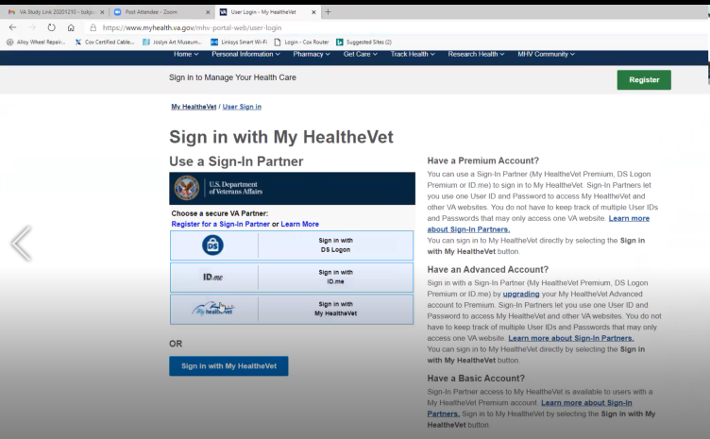

* **What makes you choose that option over the others?** Uh oh… *Participant thinks for a moment.*I don’t know, I think it is commonality. I suppose I could have gone with the other one, but…

*Participant get distracted by log-in; steps away to look up his password on his other computer; he did not have his MHV log in saved on this computer. Interpreting “commonality” to mean he’s on MHV, so he uses the MHV credential.*

*Participant navigates to Secure Message from the Messages link on the four main tiles of the homepage. Once he lands in the Secure Message page, he scrolls down the page a bit but quickly finds the green CTA ‘Compose Message.’ Easily completes this task.*

So on this one I would go to messaging then say compose, then it allows me to select a group, see the [doctor’s name]. So he was my old [doctor] and my new [doctor] isn’t in here.

*Participant opens the ‘To’ drop down menu. There is an ‘Edit List’ tool tip next to this field, but we do not explore if that will help. Check with SM team on this functionality.*

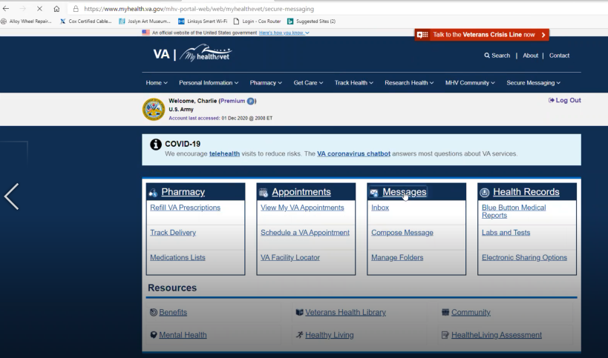

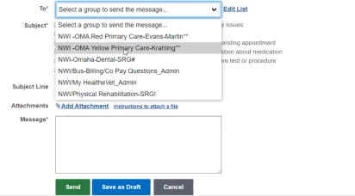

Yellow clinic was where I was when—I told you in 2013 when I first started and they kicked me out in 2015? When I came back they put me in the Red Clinic. I tried to get back with [Yellow Clinic Provider] because I really liked him. And so here’s some other things I’ve communicated with. *Participant points to the other options in the ‘To’ drop down.*

*Participant only has one message showing in his inbox; text above the inbox table reads: Based on your preference settings, displaying messages from 9/10/2020 to 12/10/2020. Future research q: is this a long enough history?*

* **How would you refill a prescription you have with the VA?**

That is easy money there, click Pharmacy and Refill VA Prescriptions. This on here I just received it and this on all I would do was click here and submit refill.

*Participant uses top nav to navigate from SM page (see screenshot). Easily completes this task; very familiar with this system.*

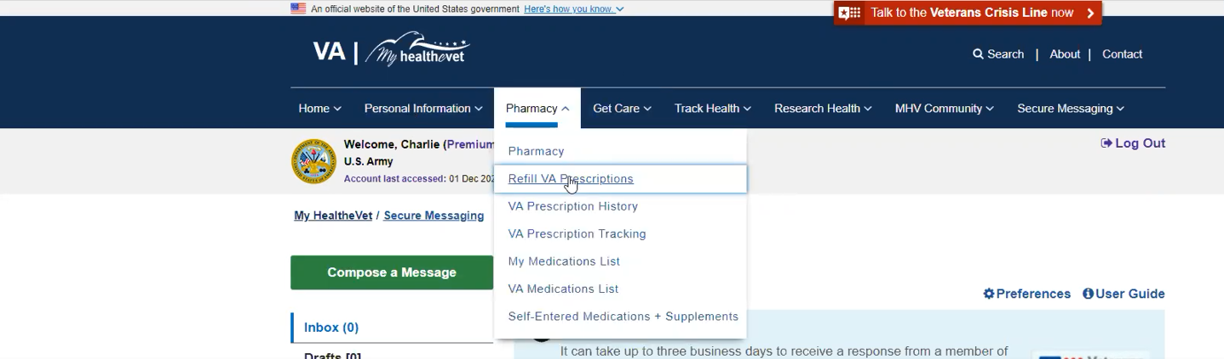

Okay, you’re fixing to see all my prescriptions so don’t get scared! *How does participant’s situation of taking daily medication influence his use of and attitude toward MHV?*

This one here, I just received a few days ago. *Participant indicates the first Rx in the table; it has a blue CTA ‘*Track Delivery’ *next to it.*

Then I’d click this here [check box next to medication] and then all I have to do is click Submit Refill.

* **Do you primarily use this feature, or are there other ways that you like to [refill prescriptions]?** I always use this, it seems easy to me and it’s what I’ve learned. I know things are continuously evolving and improving, but so far this is good.

I know in VA.gov there’s an option to do this but I haven’t used it there. *Participant understands the connection between MHV and VA.gov; seems to expect Refill Rx would be a separate tool in VA.gov as opposed to a redirect to MHV.*

* **Have you used the “Track Delivery” feature before?** This part is frustrating. When I put in a refill, sometimes it offers tracking but others it don’t. I think they all should have it.

I’ll click Track Delivery and see what it says. *Participant reads the date it was shipped; has to click USPS tracking number and then ‘Continue’ to see tracking info. Recommendation: display tracking info without multiple clicks.*

* **Do you receive Rx at the same time or are they sent individually?** Almost always they are individually packed but they could save money if they did it together.
* **How would you go about checking the date of an upcoming medical exam you have for a disability claim?**  Are we talking about a C&P exam? I have had a few. Once I got my medical records, I realized I had a lot going on and decided to apply for stuff [more disability claims]. So I’ve done a few applications, and done a few C&P exams. *Participant mentioned earlier that his first disability claim he completed without his records.*

In the beginning, I would get a call then a letter. I’d get phone information and be able to contact the provider if I had to reschedule or cancel. I had a hearing exam so I had to drive an hour away; I was surprised, but I know that’s how the VA works with contracting providers to conduct those exams. In the past few years it seems like the medical exam company like LHI, something EQ, I should know this. All three companies—I’ve had exams from each of them--they contact by phone, sent emails, sends a link to create an account at their website. It allows me to go online to fill out the portion of the DBQ--it is a disability benefits questionnaire. It is the document that they submit to the VA after the exam. The DBQ correlates to the statutes that covers veteran disability.

For instance: My shoulder replacement, at the end you are given an automatic 30% for the dominant shoulder and a 20 percent for non-dominant but are given 100 percent while recovering. At the end of one year and your shoulder is perfect, you are assigned 30% and you move forward. If you feel like there’s issues with your shoulder, you can apply for an increase, which is what I’ve done.

*Participant recites the justified use cases in the statutes for shoulder replacement recovery. Has expert understanding in how range of motion, weakness, and pain correspond to VA disability ratings post-recovery.*

Since my range of motion is over 90 degree it doesn’t affect my rating. If I have severe pain, it’s 60%. If I have severe weakness, it’s 60%.

I went for a C&P exam in October for my shoulder because of limited range of motion, but the pain isn’t that bad. The examiner had me rate my shoulder pain, severe or moderate? I said moderate. So she fills out the questions that they send back to the VA. On the questionnaire it says “Does the Veteran have moderate or severe pain or weakness in the shoulder?” I have serve weakness but moderate pain. So she only asked about the pain, not the weakness. She submitted it back and they continued it at 30 percent stating no weakness. I have severe weakness, and this is my dominant hand. If I want to use a hammer after three whacks it gives out if it is above my waist.

So she asked the question wrong, and I didn’t catch it. After I get a rating and a letter, I read it and go and research it. So I got a copy of the exam and I read it. It is two things in one question and because of that I am just at 30 percent and appealing. The DBQs are geared toward the statutes. The examiner is looking for what corelates directly to the VA.

* **The contractors send you a link to a separate website from MHV?** Yes. The contractors have them but I don’t think I have them on here.

*Participant looks for a saved link in his browser’s bookmarks. He has a combination of VA related links and personal links organized in one list. Related to VA:*

* + eBenefits
  + MHV
  + Nebraska Legislature Statute 28-318 and 28-319
  + United Health Care
* **How would you pay a VA health care bill, such as a copay?** I have paid co-pays. The day I got kicked out of the [VA health care] system, I went to the window in the VA hospital and actually paid them.

The others I cannot actually remember how I paid them. I don’t know if I received a bill and sent a check. If I had the opportunity to pay online I’m sure I did that.

**Branding and trust (5 minutes)**

Now I’d like to ask for your thoughts on My HealtheVet. (Confirm that participant has used My HealtheVet previously. If not, amend questions below to capture their first impressions while looking at a logged in account.)

* **How would you describe My HealtheVet to a fellow Veteran?** (Note if they mention MHV coordinators, newsletter, or articles -- something outside the patient portal). Well, there’s a ton of information on it.

*Participant navigates to home page.* Really what I use it for are the 4 big boxes there. I would tell them that it allows you to monitor your appointments, schedule your appts, talk to the health providers, review, or download your medical records or tests and refill the prescriptions.

I know there is more information. I have looked through there. *Participant points to links under* Resources*.*  Benefits, Mental health, Veterans health library and health living. I have looked at them, but I think it is a good resource to monitor the health care and communicate with your health providers.

* **Were the extra resources helpful; anything that you used?** I cannot say I really have; I might have read through stuff but I use eBenefits and va.gov for my benefit information. *Has separate workflows and websites for benefits vs. health care.*

I haven’t done anything with mental health. I read things in the healthy living section, but I know all that stuff. I stopped smoking and I should lose some wait but in the winter it is hard to do that. I think there’s good information and resources in there if you want to sit and read some of them. *Participant did not find the features and resources outside of the four transactional tasks on homepage to be valuable to him.*

1. **On a scale from 1-5, with 1 being very dissatisfied, and 5 being very satisfied, how satisfied are you with My HealtheVet?**

A 4 because I cannot communicate with my current provider [over secure message]. It is a really good tool.

1. **On a scale from 1-5, with 1 being very low, and 5 being very high, how would you rate your trust in My HealtheVet?** Oh…huh. *Participant seems to not have considered this before.* I trust it completely ; I would say a 5.

It seems to be secure, it’s just me and it has a lot of sensitive information in it that I may or may not want everyone in the world to see. It is good to see things and check on things and get questions answered.

1. **If you have a question about your MHV account or something isn’t working, what do you do?** It happened to me because I created it this account when I was in the VA system and then I didn’t get on it for a while. At that point it wasn’t so simple to try to login and the send an email to reset the password. I was in the VA there was an office to help people so I went there to reset it. I know that is one way to do that.
2. **Do you remember which office?** No I don’t remember. I think it was a Veterans Help Center or Education Center. There were 6-7 PC’s, some books, and people in there to help.
3. **Have you ever been in touch with a My HealtheVet Coordinator?** Not unless it was the person that helped me sign up for the account the first time at the VA hospital. When I first went there, I was walking by, I saw this and said I would like to do that and they helped me create an account. I showed them my card, and now I’m in.
4. **How does My HealtheVet compare with other online health tools you’ve used?** This one is really good because it communicates with my providers. We use the Methodist healthcare system here for my family and I have been to them as well but not in years because of the VA. They have a thing to do similar as this but it isn’t nearly as comprehensive.

*Participant asks if the website is “My HealtheVet” or “My Health Vet.” He has called it My Health Vet because of the URL.*

**My HealtheVet patient portal (15 minutes)**

Let's take a look at My HealtheVet together.

Moderator will ask participant to share screen if not already, or show logged in My HealtheVet account. **(5 minutes)**

1. **What do you wish this website did that it doesn’t do right now?** The one thing that is not on here is on my UHC website, it shows me when a bill has been submitted and the cost submitted/allowed amount and what the insurance has paid as well as how much I need to pay. This site does not show dollar amounts for exams here. Maybe that’s not even part of this system.

But then you’d know…I thought I saw something in messages. *Participant navigates to Secure Messages and looks at drop down in ‘To’ field. There is an option for Billing and Co Pay Questions.*

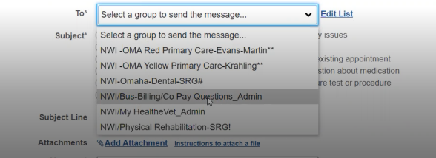

*Participant clicks on the billing option in the ‘To’ field and expects the radio options to change for ‘Subject.’ He tries to find an old message but because the SM only shows the last 3 months of messages, he’s not able to quickly find the message he’s looking for.*

Let me see what it says. Oh, that didn’t help me. I would need to go to my inbox, this is only old message. It doesn’t show the bills, it would be nice to know what they bill for but I do see it on UHC.

I had a total shoulder replacement, and because they never billed my private insurance for it, I never knew what it cost. So I’m curious.

**Thank you and closing (2 minutes)**

Final questions or feedback: No I think I am good.

Well we really appreciate you taking the time to share your thoughts with us today. Your feedback is so helpful to us as we continue to work on the site and make sure it really works for Veterans.

Lastly, do you know any other Veterans, caregivers, or service members who might be willing to participate in a future user research session? If Yes: Thank you! I'll have our team send you an email with a little blurb that you can pass along.

Great, well thank you so much again, and enjoy the rest of your day!